LAMPIRAN B

TAMPILAN ENVIRONMENT UJI COBA

1. Environment Linux

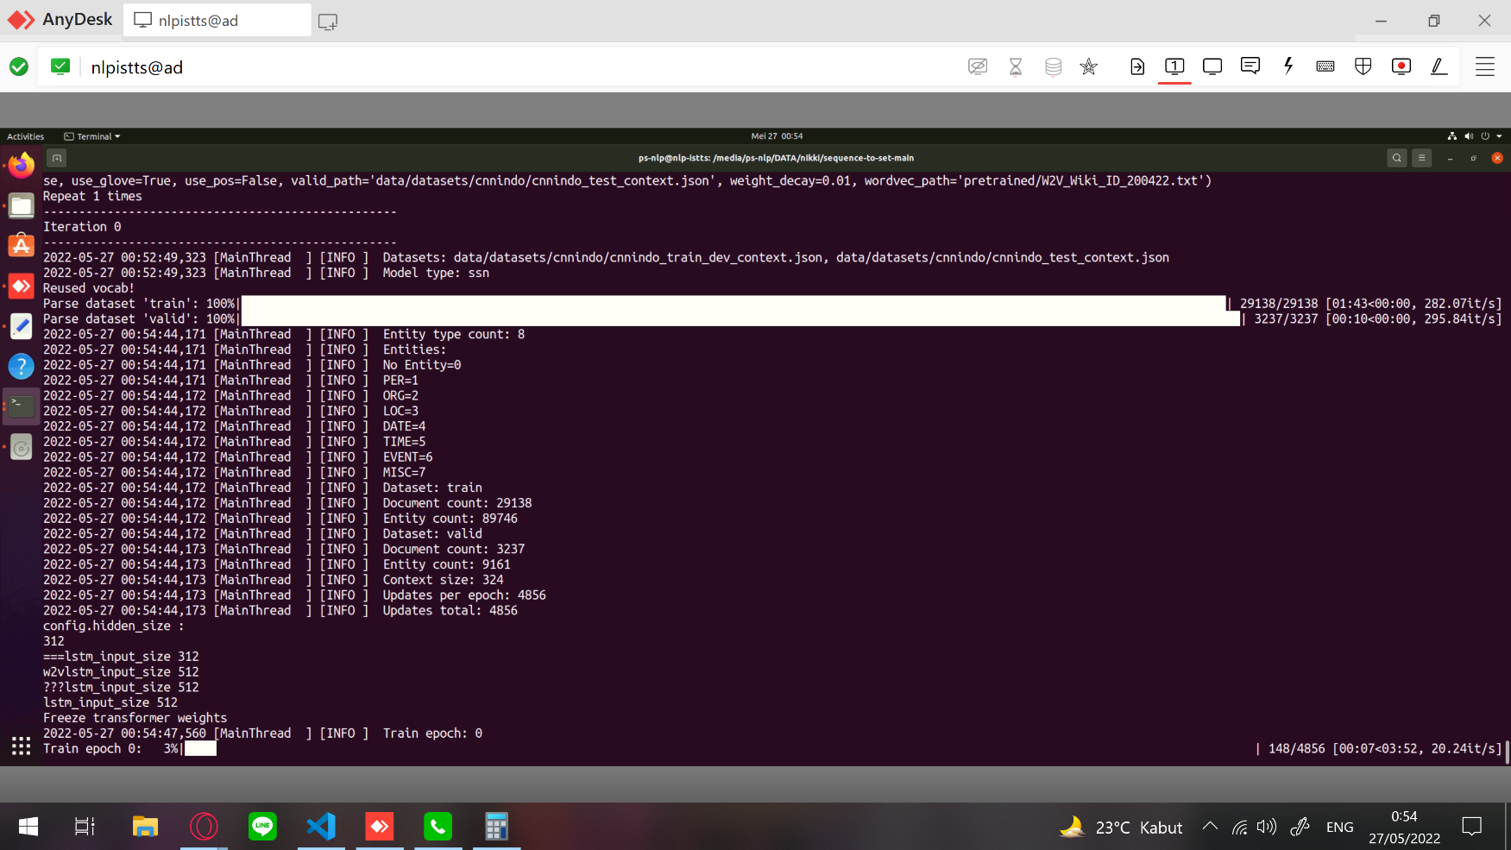

1. Environment Google Colab Pro
2. Google Colab – Error: CUDA out of memory

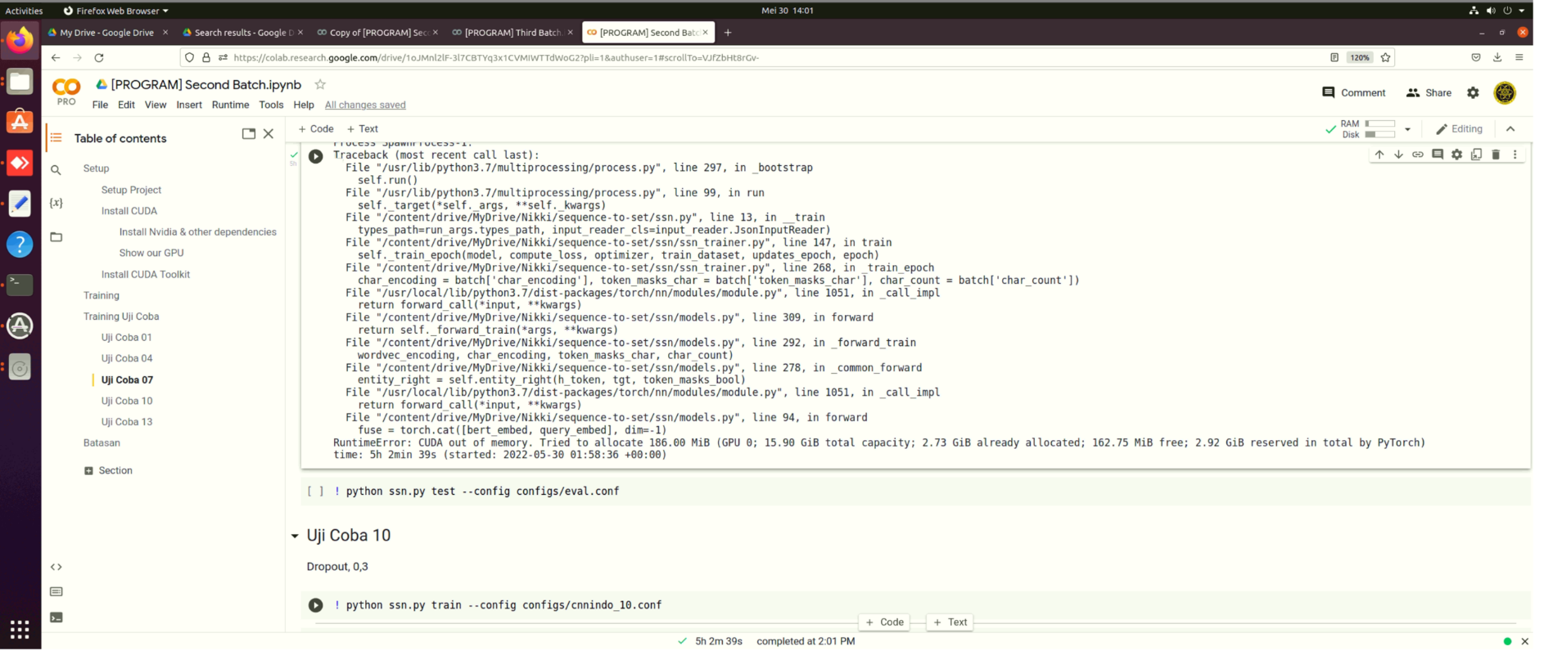

1. Google Colab – Error: Unexpected error

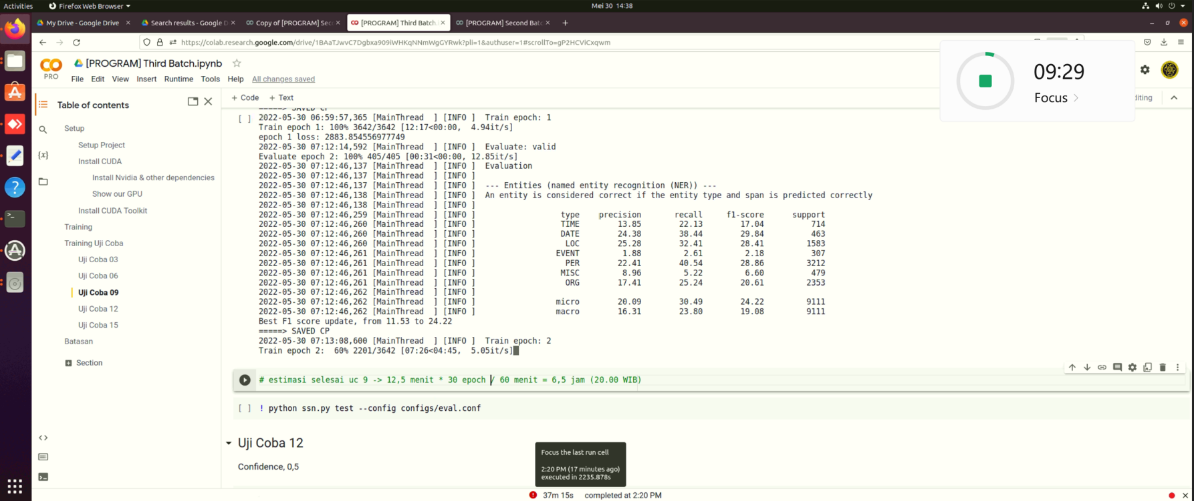

1. Google Colab – Error: Runtime Disconnected

